# Web Design Project Report

## Name: Cian Curley

Student ID: x22490814

## Links:

Github: ________

Deployed: ________

Stream presentation video: ________

## Requirements:

Beach yoga website including

* 2 locations
* Class times
* information

## Screen shots of Wireframes:

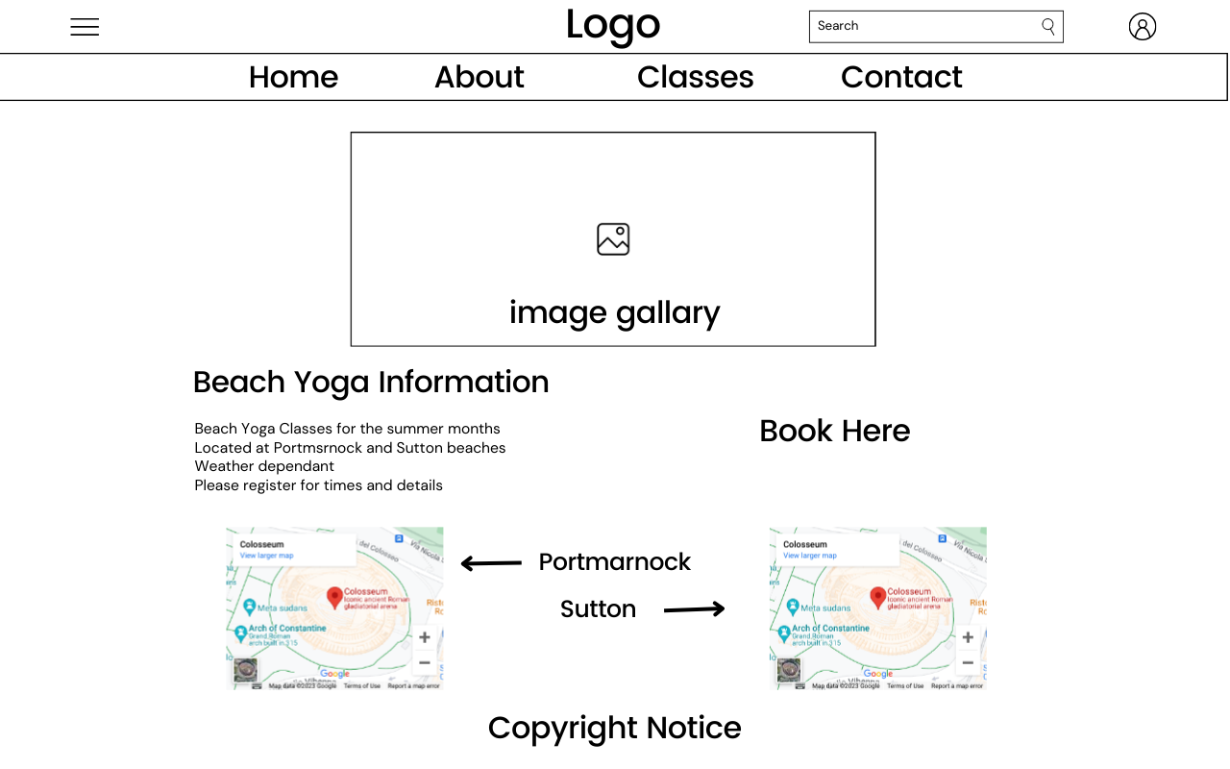

## Screen shots of Mood board:



## How the website meets web standards:

## Coding challenge by team member 1:

## Coding challenge by team member 2:

## Coding challenge by team member 3:

## List of tasks assigned to team members: